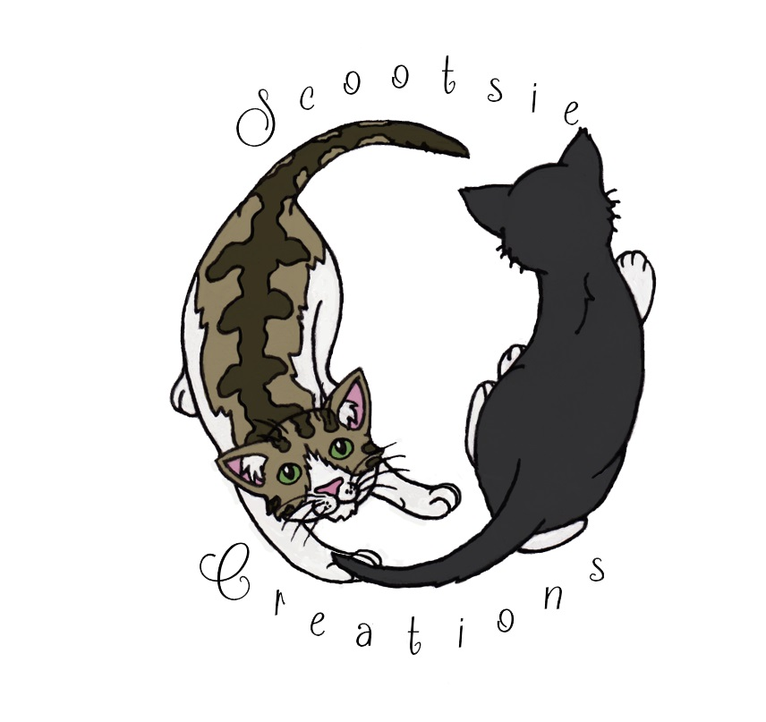
‘Scootsie Creations’ Commission Info – Pet Portraits and Other Requests
I currently work traditionally, primarily in acrylic paints on canvas (stretched or board) or the most appropriate paper and card. Do you want an illustrated character or an animal portrait? – I’m happy to do either.
Options:
A5 or A4 Black and White Sketch on sketch paper, black ink or pencil. Illustrative or more realistic. This can be delivered in physical form or scanned in and sent via e-mail.
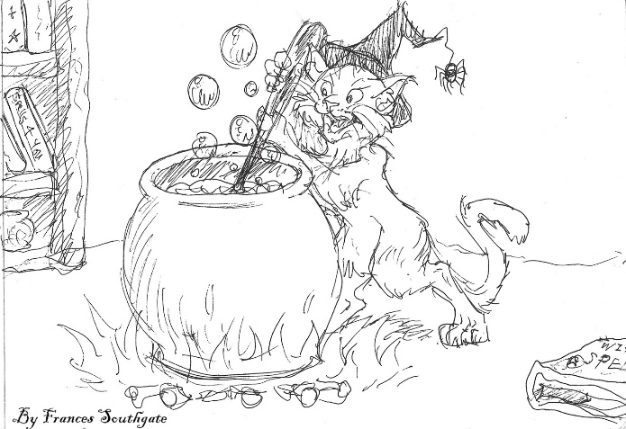
Paintings
A5 or A4 Painted on acrylic card (Gloss linen textured paper, acid-free, 330 gsm)
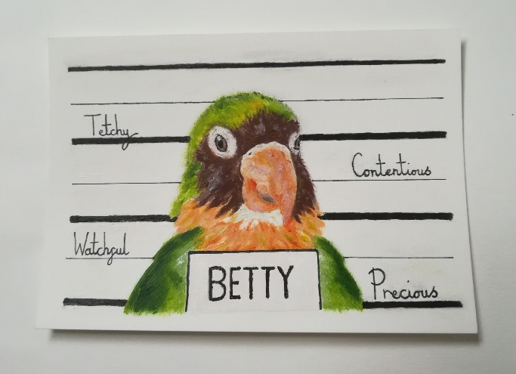
Mini canvas portraits/other
Lightweight and easily moveable, display your little arty canvas and easel wherever you like.
£15 – upwards
- 10 x 10 cm (plus 1 cm thickness) stretch canvas on coloured easel ;
- 16 x 12.5 cm (roughly 1 cm thick) stretch canvas on coloured easel ; - 13 x 18 cm canvas board (no easel) 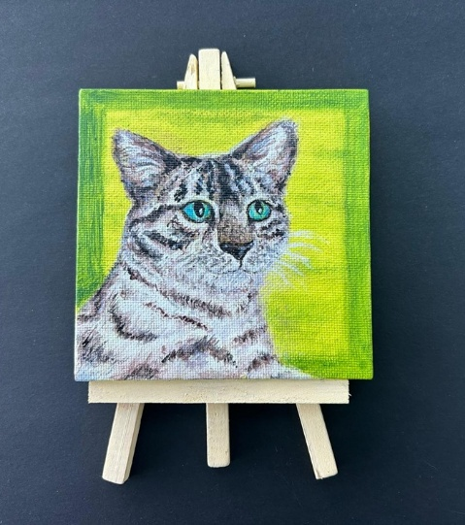 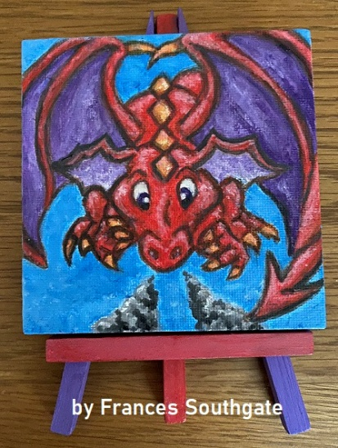
Larger canvas portraits/other
Stretch canvas pieces with their added thickness are more suited to hang up as they are with (Wooden wedges included with some canvases.) Canvas board have no fixings, but allows for your own prop or ability to frame how you wish.
£35 – upwards
Stretch canvas and canvas board, ranging from 23 cm to 50 cm measurements. Please ask for canvas stock sizes I currently have; I will accommodate your preferences as best as I can.
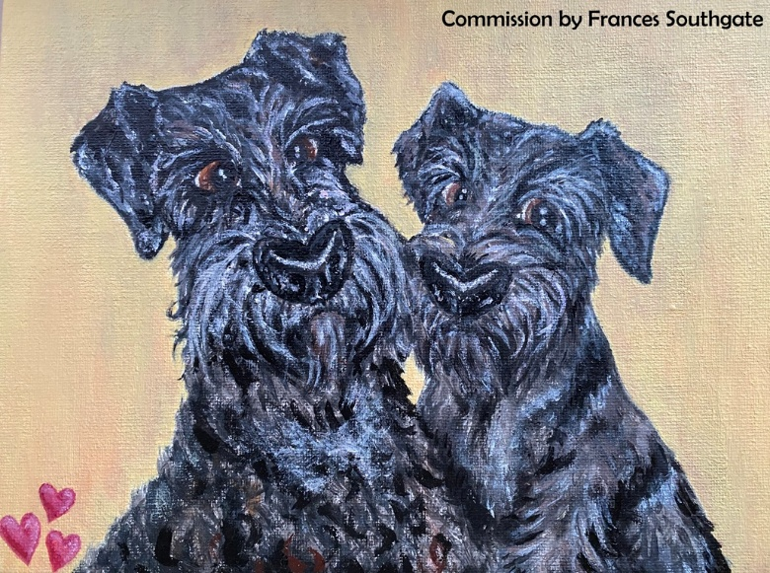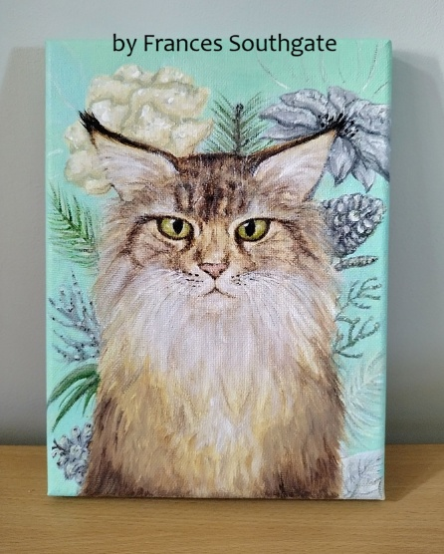
Process:
Through discussion, usually by e-mail, we will work out how best to create your art piece and calculate any additional costs, ensuring you are happy with what is agreed.
Please supply a few photographs of your pet, preferably in good lighting that shows off their true fur/feather/scale colour the clearest!
I can send you updates on how the picture is going, and you can let me know if there are any edits that should be made to colouring, etc., before I finalise.

Additional info:
Prices start from around £15 and price increases depending on your requirements. For example, if you want more than one character or pet, the amount of detail required, preferred size of canvas/card/paper, additional background colours, portrait or full-body, etc.
I will endeavour to start on your piece ASAP, but please allow for other commitments I may already have for how long the piece might take.
Paypal payment option available.
Local and further afield options. Commission prices do not include postage & packaging, which will be calculated separately.
Any information not here, please do ask! I hope to create as smooth and positive a commissioning experience as I can! I look forward to hearing from you.

See www.scootsiecreations.com for more commission examples. Contact at scootsiecreations@gmail.com

Frances Southgate / Scootsie Creations - 2025

